Table 2. Representatives of differentially expressed proteins on photosystem identified in CLas-infected leaf petioles.
UniProtKB Entry |  | Description |  |  |  |  | Fold Change | Relative change (Mock/Treatment)
AOAO67GIE1 |  | Oxygen-evolving enhancer protein 1 |  |  |  |  | -2.1 |   
AOAO67DPLO |  | Oxygen-evolving enhancer protein 2 |  |  |  |  | -2.03
AOAO67EBB3 |  | Ribulose bisphosphate carboxylase/oxygenase activase 1 |  |  |  |  | -1.79
A8C172 |  | Photosystem I reaction center subunit II |  |  |  |  | -1.71
AOAO67GJW2 |  | Oxygen-evolving enhancer protein 3-2 |  |  |  |  | -1.67
AOAO67FFU3 |  | Carbonic anhydrase 2 |  |  |  |  | -1.66
A8C1A6 |  | Photosystem I reaction center subunit IV A |  |  |  |  | -1.64
AOAO67FZ61 |  | Photosystem I reaction center subunit II |  |  |  |  | -1.59
AOAO67HAZO |  | Protein disulfide-isomerase |  |  |  |  | -1.57
A0A067H8B2 |  | ATP synthase delta chain |  |  |  |  | -1.53
 | Fold change <0.75, |  |  | Fold change =1, |  | 0.75<Fold change<1.3.

Table 3. Representatives of differentially expressed proteins on plant defense response identified in CLas-infected leaf petioles.
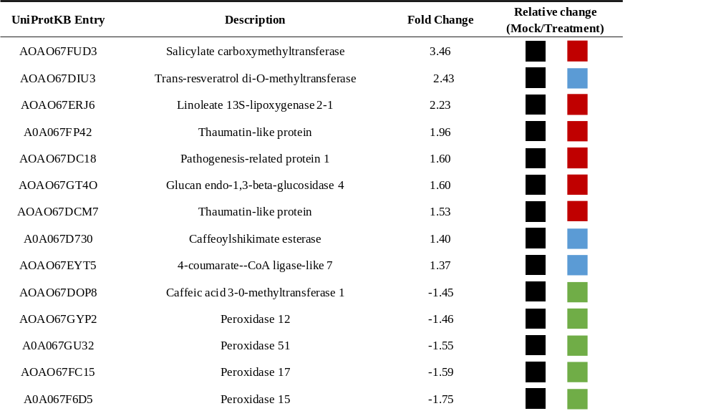

UniProtKB Entry |  | Description |  |  |  |  | Fold Change |  | Relative change (Mock/Treatment)
AOAO67FUD3 |  | Salicylate carboxymethyltransferase |  |  |  |  | 3.46
AOAO67DIU3 |  | Trans-resveratrol di-O-methyltransferase |  |  |  |  | 2.43
AOAO67ERJ6 |  | Linoleate 13S-lipoxygenase 2-1 |  |  |  |  | 2.23
A0A067FP42 |  | Thaumatin-like protein |  |  |  |  | 1.96
AOAO67DC18 |  | Pathogenesis-related protein 1 |  |  |  |  | 1.60
AOAO67GT4O |  | Glucan endo-1,3-beta-glucosidase 4 |  |  |  |  | 1.60
AOAO67DCM7 |  | Thaumatin-like protein |  |  |  |  | 1.53
A0A067D730 |  | Caffeoylshikimate esterase |  |  |  |  | 1.40
AOAO67EYT5 |  | 4-coumarate--CoA ligase-like 7 |  |  |  |  | 1.37
AOAO67DOP8 |  | Caffeic acid 3-0-methyltransferase 1 |  |  |  |  | -1.45
AOAO67GYP2 |  | Peroxidase 12 |  |  |  |  | -1.46
A0A067GU32 |  | Peroxidase 51 |  |  |  |  | -1.55
AOAO67FC15 |  | Peroxidase 17 |  |  |  |  | -1.59
A0A067F6D5 |  | Peroxidase 15 |  |  |  |  | -1.75
 | Fold change <0.75, |  |  | Fold change =1, |  | 1.3<Fold change<3, |  | Fold change>3.

